|  |  |  |  |
| --- | --- | --- | --- |
|  | **Name:** | |  |
| pact jpg1 | **Mathematics Essential**  **Test 11, 2015**  **Topics – Comparing Data sets** | | 84  = % |
| **Total Time:** | ***60*** *minutes* |  | |
| **Total Reading:** | *5**minutes* |
| **Total Working:** | *55**minutes* |
| **Weighting:** | *5% of the year.* |
| **Equipment Allowed:** | *Calculator* |
| ***You must include all working out to receive full marks*** | | | |
| **CALCULATOR ASSUMED** | | | |

1. **(1 marks)**

The box plot for the data set

1, 2, 2, 2, 3, 5, 5, 5, 6 is:

**A**

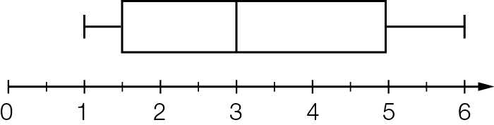

**B**

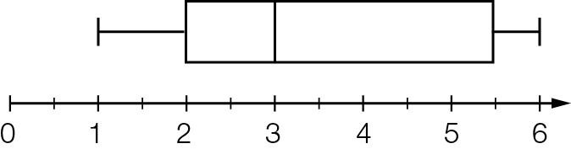

**C**

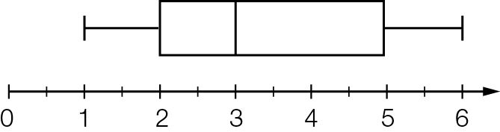

**D**

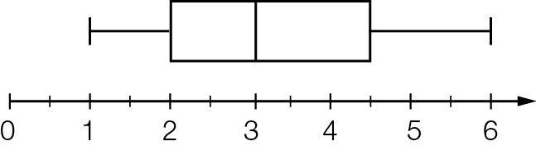

1. **(4 marks)**

Choose from the following words and expressions to complete the sentences below.

*box plot skewed dot plot independent outlier*

*scatter plot interquartile range mean median*

1. ______________ is a diagram that depicts the five-number summary of a data set.
2. The ______________ is a measure of the middle 50% of a data set.
3. ______________ is the middle score of a data set.
4. An ______________ is a score that is very different from the others in a data set.
5. The shape of a statistical distribution is said to be _______________ where most of the data scores are either low or high.
6. **(11 marks: 1, 2, 2 ,5 2)**

The following data are the years of death of a sample of 11 people buried in a particular cemetery.

1820, 1910, 1908, 1954, 1964, 1999, 1932, 2008, 1871, 1962, 1922.

**(a)** List the dates from earliest to the latest ages recorded.

**(b)** Use the list to find the:

**(i)** median

**(ii)** quartiles, and hence the interquartile range.

**(c)** Draw a box plot of the data using the scale below.



**(d)** Write a couple of sentences based on the statistics found in the earlier parts of this question.

1. **(10 marks:2, 1, 2, 1, 2, 2.)**

In 1975, a random sample of first time mothers was selected, and their ages recorded. A similar survey was conducted in 1995. The results are compared in a back-to-back stem and leaf plot below.

|  |  |  |
| --- | --- | --- |
| **1975** |  | **1995** |
| 998876 | 1 | 7889 |
| 97766655544432221111100 | 2 | 0233344456678888899 |
| 97766432110 | 3 | 01223345588 |
|  | 4 | 112346 |

1. How old was the youngest mother in 1975? In 1995?
2. Do you notice any outliers in the data?
3. Find the mode for each data set?
4. Which set of data, 1975 or 1995, is more spread out?
5. Calculate the mean of the ages in 1975. In 1995
6. What is the most obvious difference in 1995 when comparing it to the 1975 data?
7. **(24 marks: 5 , 5, 5, 5, 4)**

The data below gives the average monthly minimum daily temperatures of two Australian cities. The months are in order: January to December.

City X: 12, 12, 11, 9.1, 7.1, 5.1, 4.5, 5.1, 6.4, 7.8, 9.3, 10.8

City Y: 13.6, 13.8, 11.5, 6.9, 4.2, 1.4, 0, 1.3, 4, 6.6, 9.8, 11.9

**(**a) Find the five-number summary for each city.

**(b)** Draw a box plot for each of the two cities.

**(c)** Write a couple of sentences comparing and contrasting the two cities.

1. **(10 marks: 2, 2, 2, 2, 2)**

30 girls and 35 boys participated in an intramural bowling league. The two-sided stem-and-leaf plot below shows the highest score of each of the participants. Use the two-sided stem-and-leaf plot to answer the following questions:

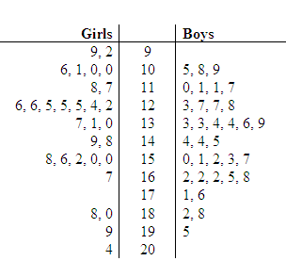

1. What was the range for the highest scores for the girls? What was the range for the boys?
2. What was the median for the highest scores for the girls? What was the median for the boys?
3. What was the mode for the highest scores for the girls? What was the mode for the boys?
4. Did a girl or a boy have the highest score in the intramural bowling league?
5. **(4 marks)**

|  |
| --- |
| For each graph or table describe the data as symmetrical (or approximately symmetrical), positively skewed, negatively skewed or bimodal. |
| **a) b)** |
| **c) d)** |

1. **(6 marks: 2, 1, 1, 2)**

Describe the sets of data displayed in the following graph, using the terms symmetrical, positively skewed, negatively skewed and bimodal.



1. Boys?
2. Girls?
3. **(14 marks: 2, 2, 2, 2, 2,2 ,2.)**

|  |
| --- |
| A cinema complex manager records the ages of 20 people entering the complex on a weekday. One sample is taken at 2pm and another at 9pm.  2pm: 58, 67, 43, 76, 69, 27, 77, 38, 43, 67, 67, 40, 79, 35, 59, 78, 58, 70, 59, 65.  9pm: 34, 25, 47, 30, 42, 17, 20, 46, 28, 22, 31, 46, 52, 41, 45, 25, 25, 42, 23, 34. |
| 1. Using the data draw an ordered back-to-back stem and leaf plot. 2. Find the mode of both sets of data. 3. Find the the median of both sets of data. 4. Find the range for both sets of data 5. Are there any outliers? If so state the outliers 6. State one similarity between the data sets 7. State one difference between the data sets. |
|  |